Mali

## GNI per capita and development level

The data set shows the GNI per capita and development level of the country each year.

## # A tibble: 19 x 5  
## country iso3c date GNIperCapita devCategory  
## <chr> <chr> <dbl> <dbl> <chr>   
## 1 Mali MLI 1996 511. Low Income   
## 2 Mali MLI 1998 546. Low Income   
## 3 Mali MLI 2000 551. Low Income   
## 4 Mali MLI 2002 586. Low Income   
## 5 Mali MLI 2003 638. Low Income   
## 6 Mali MLI 2004 628. Low Income   
## 7 Mali MLI 2005 648. Low Income   
## 8 Mali MLI 2006 653. Low Income   
## 9 Mali MLI 2007 654. Low Income   
## 10 Mali MLI 2008 666. Low Income   
## 11 Mali MLI 2009 664. Low Income   
## 12 Mali MLI 2010 682. Low Income   
## 13 Mali MLI 2011 685. Low Income   
## 14 Mali MLI 2012 658. Low Income   
## 15 Mali MLI 2013 658. Low Income   
## 16 Mali MLI 2014 689. Low Income   
## 17 Mali MLI 2015 713. Low Income   
## 18 Mali MLI 2016 729. Low Income   
## 19 Mali MLI 2017 742. Low Income

## GDP growth and economic growth classification

The data set shows the GDP growth and the ecomic growth classification of the country each year.

## # A tibble: 19 x 5  
## country iso3c date GDPannualGrowthRate GDPgrowthCategory4  
## <chr> <chr> <dbl> <dbl> <fct>   
## 1 Mali MLI 1996 7.06 fast growth   
## 2 Mali MLI 1998 7.57 fast growth   
## 3 Mali MLI 2000 -0.0608 negative grwoth   
## 4 Mali MLI 2002 3.11 moderate growth   
## 5 Mali MLI 2003 9.12 fast growth   
## 6 Mali MLI 2004 1.56 slow growth   
## 7 Mali MLI 2005 6.53 fast growth   
## 8 Mali MLI 2006 4.66 moderate growth   
## 9 Mali MLI 2007 3.49 moderate growth   
## 10 Mali MLI 2008 4.77 moderate growth   
## 11 Mali MLI 2009 4.81 moderate growth   
## 12 Mali MLI 2010 5.31 moderate growth   
## 13 Mali MLI 2011 3.21 moderate growth   
## 14 Mali MLI 2012 -0.837 negative grwoth   
## 15 Mali MLI 2013 2.30 slow growth   
## 16 Mali MLI 2014 7.08 fast growth   
## 17 Mali MLI 2015 6.17 fast growth   
## 18 Mali MLI 2016 5.85 fast growth   
## 19 Mali MLI 2017 5.31 moderate growth

## Development trend

The plot shows the development trend of the country.

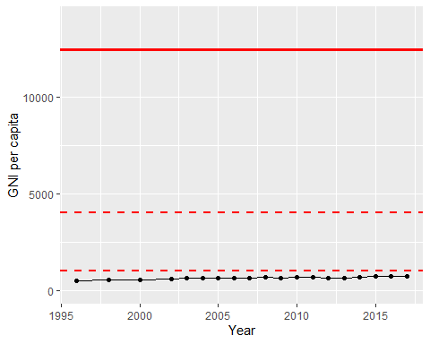

GNI Per Capita Trend